 Introduction to Robotics

Group 13

Week 08 Date 27/03/15

Fergal Lonergan, Ruairí O’Donoghue, Kevin O’Flannagáin

**Assignment:** 4 [Search and rescue](https://csimoodle.ucd.ie/moodle/mod/resource/view.php?id=27306)

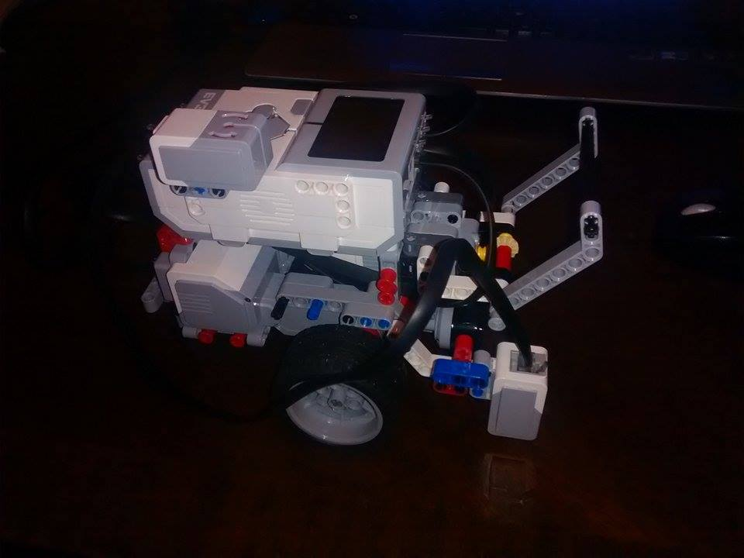 Robot used for assignment.

**Goal:** For this week’s assignment we had to imitate a [Search and rescue](https://csimoodle.ucd.ie/moodle/mod/resource/view.php?id=27306) mission in which you had to enter four ‘rooms’ which would be randomly changed for each run. For this we were advised to write four separate programs, 1 for each room, and then to use different cases to navigate the mission. In order to do this we divided the work up. Each person took a room before entering the lab, in order to speed up the process, then we wrote the final room and combined each programme into one in the lab.

**Robot design:** We decided to take advantage of the gyro, the ultrasonic sensor, and the colour sensor to complete this challenge. We used the servo motor to pick up the man. This was done by attaching the servo motor to a Lego ‘hook’. When the man was in range of the hook (this was determined by the ultrasonic sensor) the servo is activated and the man is lifted off the table.

We took the colour sensor from the back of the robot and put it at the front, facing forward instead of down at the ground. This allowed us to see the colour of the black box and the fire room. However we realised that this was unnecessary while we weren’t doing the random rooms part of the task and returned it to its former position at the back facing the ground.

**Programs:** In the end our program was designed with the fact that we knew the layout of the rooms in mind. We were unable to complete the randomised room challenge on time. The robot started with its front facing the room with the man in it. This was decided so that we would minimise the chance of our robot not being aligned with the man properly when it tried to pick it up by the hook on its back.

The robot moved on to the empty room next and played the analyse noise. Next was the room with the fire and then the room with the wall jutting out and the finally back to the start.

**Learned:** In this challenge we learned that it is important to collaborate between team members on a project. We noticed that each member had a slightly different coding style and that in order for our program to run successfully these would all have to match. We also learned that dividing the one large task into smaller tasks simplifies the problem and speeds up the coding process.

During the first lab we didn’t get much testing done as we were focussed on writing the code for the more difficult challenge, where the rooms would be randomised at the start of each run. However, during the second lab we realised that this was a mistake and altered the code we had written to work for the simpler, non-random task. The fact that we had a second lab to complete the challenge helped a lot and we were able to make changes and improve our code over the break for Easter. We did make an attempt at the randomisation section of the assignment and this attempt can be seen at the bottom of the program code in a comment block.

**Finished Code:**  In the end we organised each room into a separate function to simplify the program. The turning angles and speed were altered until they worked properly. This was done by testing the code on our table and on the challenge table (using our robot).

**Work Distribution:** Each member took a room before the lab, Fergal (empty with beep), Kevin (fire), and Ruairí (black box). Kevin and Ruairí then completed the lab as Fergal had an orthodontic appointment and couldn’t make the scheduled lab time for the first lab.

As Fergal was not going to be present for the first lab session he undertook with the Goal, Learned and Work Distribution aspects of the report, whereas Ruairí wrote the sections on Programs and Finished code as well as commenting our code submission, and Kevin took the picture, video and completed the Robot Design section as well as collating the final submission of the report.